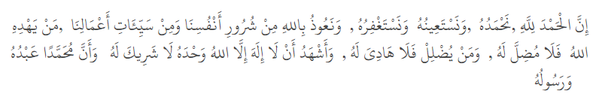
Khutba 1
يَا أَيُّهَا الّذِينَ آمَنُوا اتَّقُوا اللَّهَ حَقَّ تُقَاتِهِ وَلَا تَمُوتُنَّ إِلَّا وَأَنْتُمْ مُسْلِمُونَ – آل عمران:102
O you who believe! Fear Allah as He should be feared and die not except in a state of Islam.
Qur'anic Verse on Halal Food:
Surah Al-Baqarah (2:168):
"O mankind, eat from whatever is on earth [that is] lawful and good (halal and Tayyib) and do not follow the footsteps of Satan. Indeed, he is to you a clear enemy."
This verse emphasizes the obligation of consuming lawful (halal) and pure (Tayyib) food, while avoiding anything that is forbidden or harmful. It serves as guidance to avoid what is unlawful, as doing so leads one away from righteousness.
Hadith on Halal Food:
The Prophet Muhammad (PBUH) said:
"That flesh which has grown out of unlawful earnings (haram)/ haram sources of food, the Hellfire is more deserving of it."
(Narrated by At-Tirmidhi 614, Ahmad 14192)_
This hadith highlights the importance of ensuring that one's food and income come from lawful (halal) sources. Consuming haram food can lead to punishment in the Hereafter, as the flesh grown from such sources is unworthy and subject to Hellfire.
These references underline the necessity and obligation of adhering to halal consumption and the potential spiritual consequences for disregarding this guidance.
In Sha Allah, if Allah allows me, I will try to explain the processing of halal food and the importance of halal rizk in Islam, in another day.
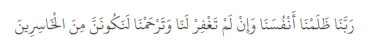
Second Khutbah
